**GIT Branching**

Name – Hritik Ray

Section – A

Objective: Commit HTML, CSS & JavaScript assignments into GIT.

**21. First take a backup of your assignments & projects. This is required because due to incorrect GIT operation you may lose your files**

**22. Create an empty directory ‘Assignments’ & cd to ‘Assignments’.**

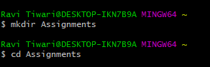

**23. Create a file README.txt inside ‘Assignments’ & write few lines about the contents of ‘Assignments’ folder.**

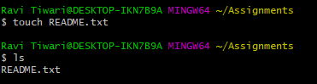

**README.txt**



**24. Commit README.txt file**

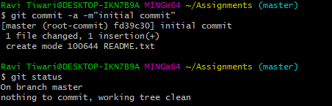

**25. Now create a new branch ‘html-assignments’**



**26. Switch to ‘html-assignments’ branch.**



**27. Copy all HTML assignments inside ‘Assignments’ folder.**

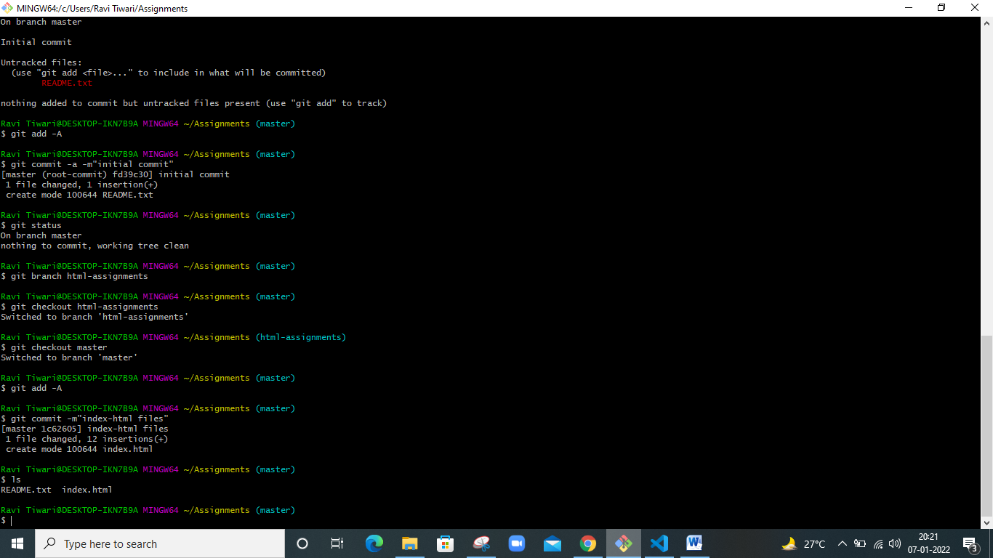

**28. Commit HTML assignments into ‘html-assignments’ branch.**

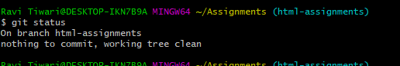

**29. Make minor changes into few files belonging to ‘html-assignments’ branch.**

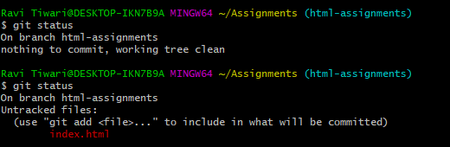

**30. Commit those changed files.**

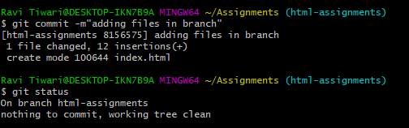

**31. Switch to master branch.**



**32. Make minor changes into README.txt file & commit those changes into master.**

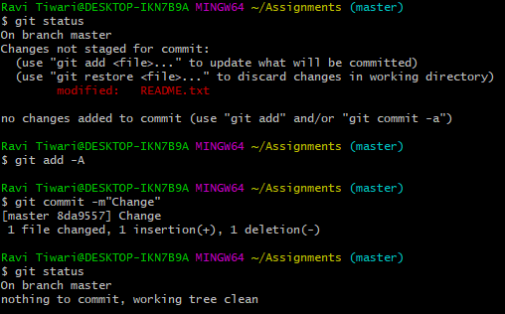

**33. Again switch to ‘html-assignments’ branch.**



**34. Make minor changes into few files belonging to ‘html-assignments’ branch.**

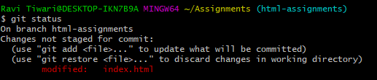

**35. Commit those changes.**

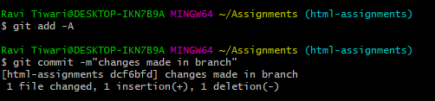

**36. Switch to master.**



**37. Merge ‘html-assignments’ branch into master. Confirm all html assignments are shown in master.**

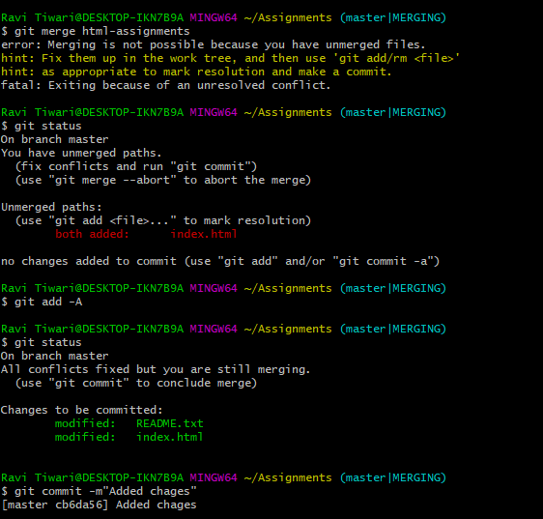

**38. Finally delete the ‘html-assignments’ branch.**

